# **Growth Accounting**

## Weekly Total Users -:

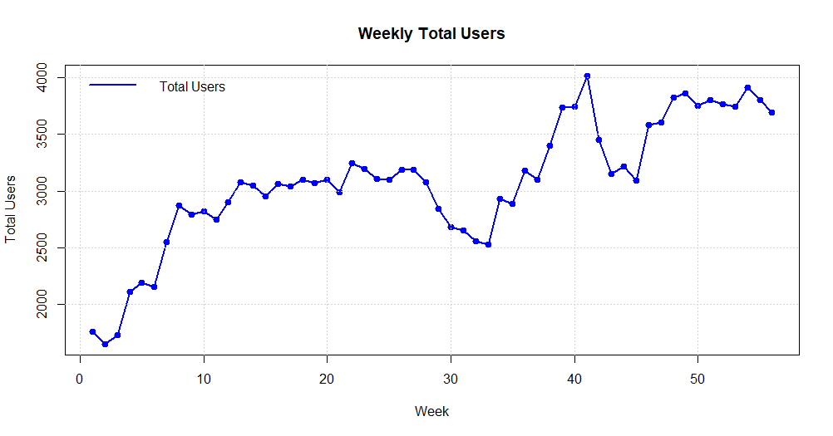

Results-:

* We can see an uptrend in the total number of users of our application.
* However, the trend remained mostly constant between a span of 15 to 21 (i.e., approximately 10 weeks).
* We can also see a bottom in the uptrend with 2,529 total users in the 33rd week.
* In the 33rd week the total number of users who have come to visit the ‘brand’ has dipped sharply. The reasons can be the brands workings at the time or the external influences that had caused a sharp decline.
* In the 50th week, the trend of users visiting the brand is though increasing but is fairly constant.
* The highest number of users visited the brand for 10 weeks again. This also indicates that the longest that the brand can hold users is for approximately 10 weeks.
* The user’s interaction also suggests that brand has been able to keep customers who have been retained and stayed for a longer period of time but with a decline rate.

## Monthly Total Users -:

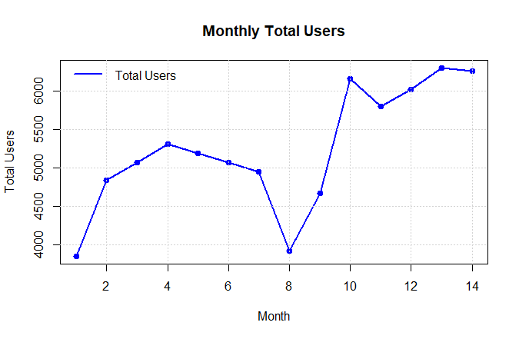

Results-:

* The Above graph gives the total number of unique that joined in that particular month.
* After Month 3, the total number of users declines gradually, dropping to around 4,600 users by Month 6.
* The decline continues sharply in Month 8, reaching the lowest point at approximately 4,000 users.
* This period of decline might reflect user churn, market saturation, or reduced effectiveness of user retention efforts.
* Rapid Increase (Months 9-11)
* Starting in Month 9, there is a significant uptrend, with the number of users increasing rapidly and peaking at about 6,200 users in Month 10.
* This sharp increase suggests a major event, such as a successful marketing campaign, product launch, or seasonal factors attracting new users.

## Weekly New Users -:

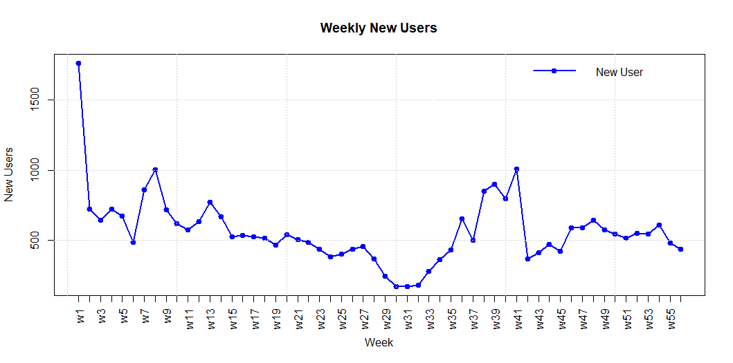

Results -:

* Assuming that all the users in week1 will be new user we start our analysis.
* The number of new users dipped around week 29-31.
* The graph shows another notable increase starting around Week 39, with peaks around Week 41 and Week 43, reaching 600-700 new users.
* Possible reasons might include end-of-year promotions, holiday season activities, or the introduction of new features.
* There’s a more gradual but steady decline from Weeks 10 to 29, where new users consistently fall below 500 and reach a low point around Week 27.
* This period might reflect market saturation, less effective marketing efforts, or external factors reducing new user acquisition.
* Declines in the middle period might be due to competitive pressures, market saturation, or ineffective marketing strategies.
* The end-year stabilization suggests a balanced acquisition strategy maintaining a consistent influx of new users despite natural fluctuations.
* The graph illustrates typical trends in user acquisition with sharp initial interest, periodic boosts likely due to marketing efforts, and inevitable declines as campaigns lose momentum. Understanding these patterns helps in planning strategic interventions to maintain or boost user acquisition throughout the year.

## Weekly Churn Customers -:

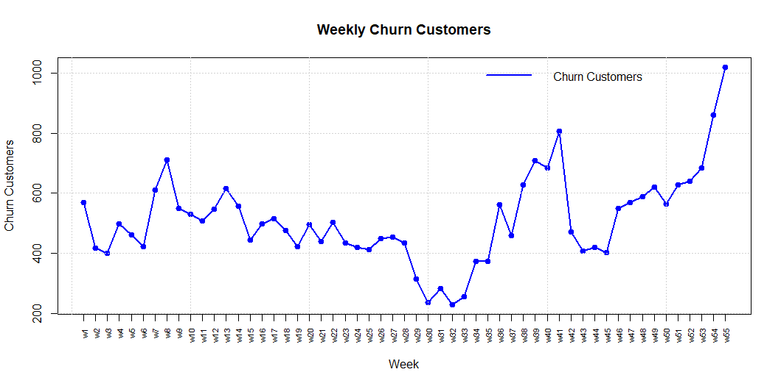

Results-:

Churn customers mean the number of customers who stooped doing business with our company.

* We can see a slight downtrend in the graph in the starting weeks (i.e. week5 to week25)
* The low number of churn customer in the weeks between 29-33 is due to the low number of weekly total users around that week itself.
* Title and Labels: The chart is titled "Weekly Churn Customers". The x-axis represents the weeks, while the y-axis represents the number of churn customers.
* Trend: The number of churn customers fluctuates significantly over the weeks. There are notable peaks and troughs in the data.
* Peak Points: There are several peaks where the number of churn customers is particularly high, notably around weeks 14, 30, and 52.
* Lowest Points: The lowest number of churn customers occurs around week 20.
* Overall Trend: Towards the end of the period, there is a sharp increase in the number of churn customers, reaching the highest point in the final week.
* The chart seems to depict a volatile pattern in customer churn, with significant variations from week to week. The sharp increase towards the end may indicate an underlying issue that needs to be addressed.

## Resurrected User (users who did not use the application for a span of 30 days)-:

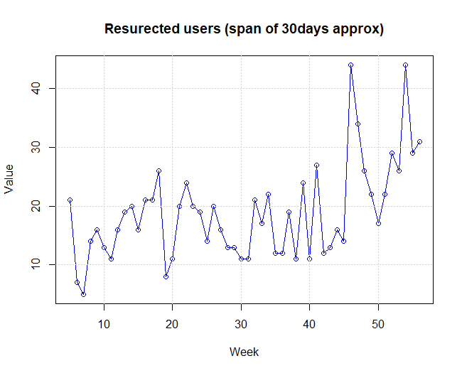

Results-:

* Resurrected users mean those users who were inactive for a period of time and after that period again started visiting the site/application.
* Assuming the period of non use of the application as 4 weeks or 1 month.
* The graph shows significant fluctuations in the number of resurrected users across the weeks.
* During the first 20 weeks, the number of resurrected users fluctuates mostly between 10 and 20, with occasional peaks reaching slightly above 20.
* From week 41 onwards, there's a noticeable upward trend with more pronounced peaks.
* A significant peak occurs around week 47, reaching above 40 users.
* Another major peak appears around week 50, also exceeding 40 users.
* Even the troughs in this period are higher compared to the initial and middle periods, seldom dropping below 20 users.
* The number of resurrected users demonstrates high volatility, especially in the latter part of the timeframe. This could indicate variability in factors influencing user resurrection.
* The increasing trend towards the latter weeks suggests growing engagement or successful reactivation strategies being employed during this period.
* The spikes in resurrected users could be associated with specific events, campaigns, or seasonal influences driving user re-engagement.

Month wise Retention Rate -:

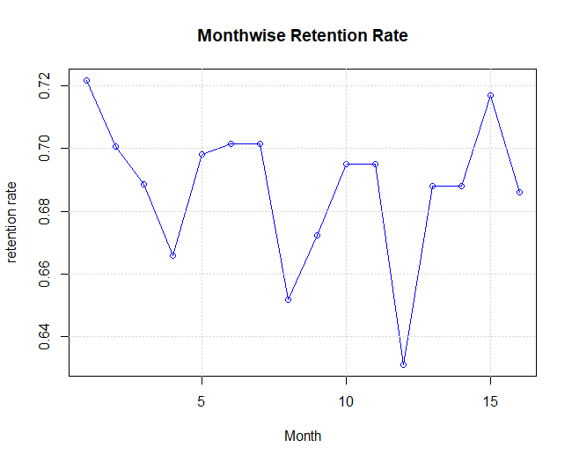

$$Retention Rate\left(1 month\right)=\frac{Number of users who were active in both the current and previous month}{Number of users who were active in the previous month} ×100$$

* The retention rate measures the percentage of users who continue to use a product or service over a period. It's calculated by dividing the number of active users in the current month by the number of active users in the previous month.
* Initially, the retention rates show a sharp upscale in the first few months after acquisition. This is typical as new users are more engaged and exploring the product or service.
* As time progresses, there are noticeable fluctuations in retention rates month-over-month. These fluctuations can be attributed to various factors such as seasonal trends, product updates, marketing campaigns, or competitive pressures.
* Despite the fluctuations, there is a consistent median retention rate observed over the entire period. This median rate indicates the baseline level of user engagement and satisfaction with the product or service.
* Significant events such as feature releases or marketing initiatives can cause temporary upscales in retention rates. For example, a new feature that enhances user experience may lead to a spike in retention as more users find value in the product.

## Quick Ratio

$$Quick Ratio= \frac{new+resurrected}{churned} ×100$$

## New Vs Churned User-:

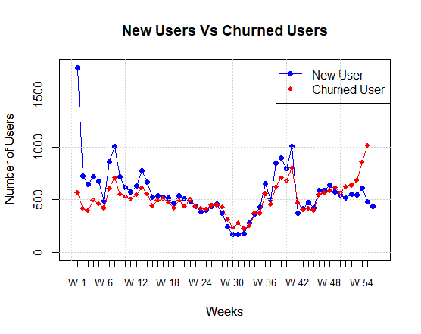

Results-:

* The line plot for new users is above the line for churned users for the first 25 weeks indicating that the application is doing good in these first few weeks.
* Finally, apart from few weeks the line plot for new users is above that of churned users indicating that yes the application is doing good.

Ques 1. Can retained customers be 0 in some week?

No, it can never be 0. According to the analysis.

Ques 2. Can churned users be 0 in some week?

No, it had never gone to 0 but it had gone very low in week30 and week32.

Ques3. Can resurrected customers be 0 in some week?

No, it had gone very low in week6 but not to 0.